Research: Portrait Photography, Viral Images and Campaigns.

Research into the photographical elements of “The Envision Cube” will take the form of basic principles of a good portrait photograph, awareness of viral images and viral campaigns that created a movement, belief or self-awareness.

Portrait Photography

Portrait photography originates from the 19th century and is today seen as one of the most widely used choices in contemporary lens media, photography and videography.

Modern day portraiture shots can vary extensively, from standard studio work that would include a subject placed in front of an often white/ back background, to more individual pieces that may include certain props, attire and locations that reflect the subject’s personality.

Today’s shoots often involve the use of DSLR camera’s and high quality photographs containing millions of pixels, instead of more traditional film cameras and large format cameras, however some portraiture photographers today still like to use more old fashioned choices.

To take the perfect portrait, some simple techniques need to be included:

- Awareness of correct exposure (avoid losing detail).
- Does a wide or narrow aperture work best?
- Choice of shutter speed.
- Increasing the ISO is necessary.
- Choice of Lens (35mm, 50mm).
- Decision of composition.
- Choice of soft lighting, natural light or flash.

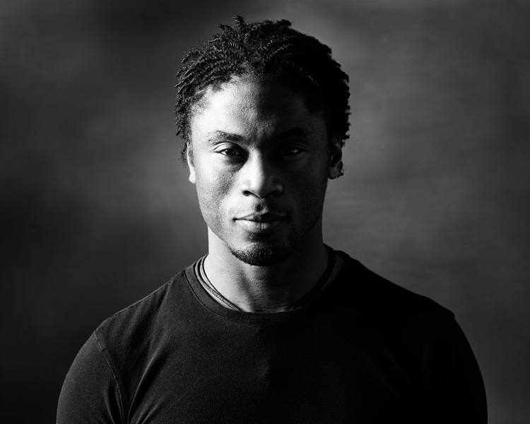
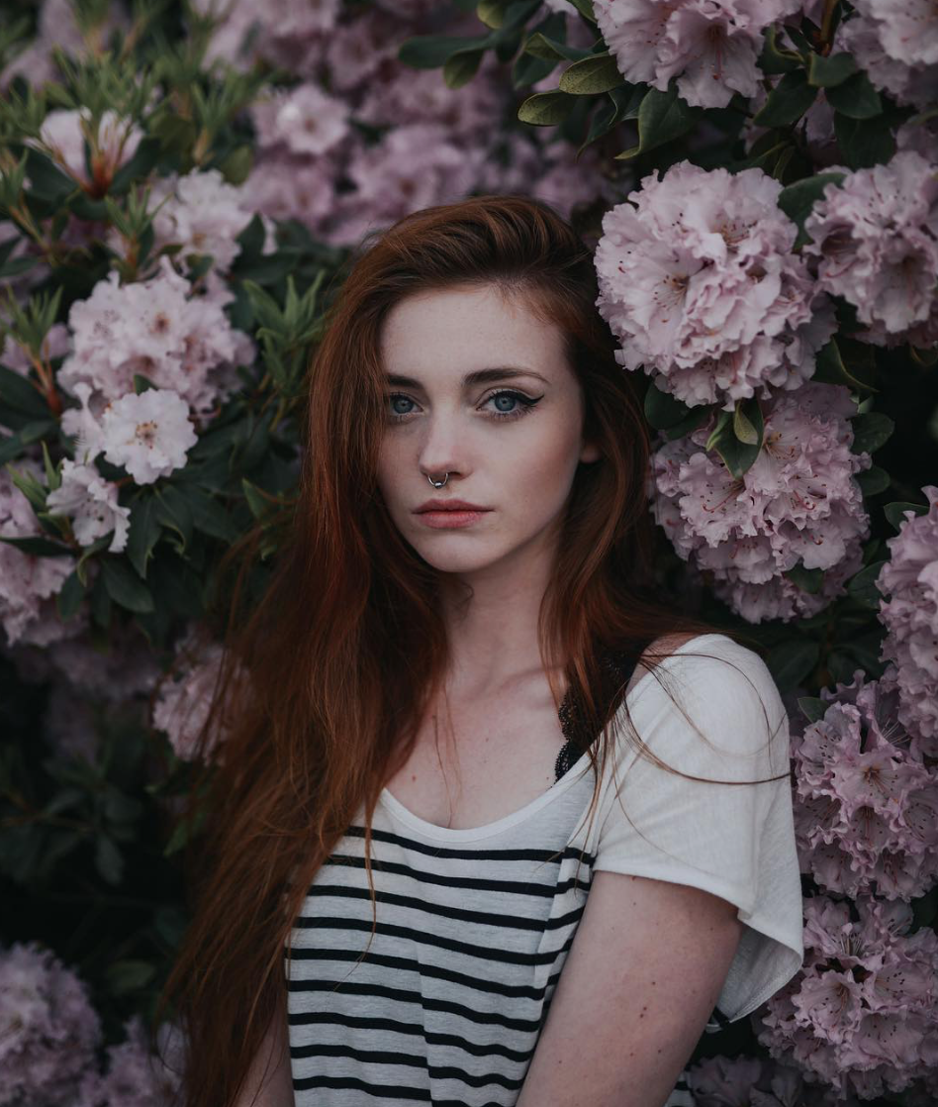
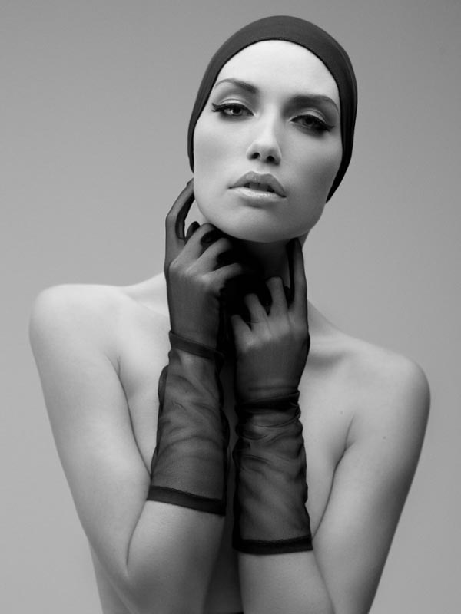

Terry Richardson

Terry Richardson is an American born photographer, most famous for his work within portraiture and celebrity culture.

The main attraction of Richardson is his ability to capture or frame the controversial, provocative or outright sexual, his photography aims to shock and provoke its intended audience.

A perfect example of how to convey a meaning through the art of portrait photography, moving away from the simple, conventional studio work and expressing a vital message that needs to be heard, something “The Envision Cube” is aiming to achieve.

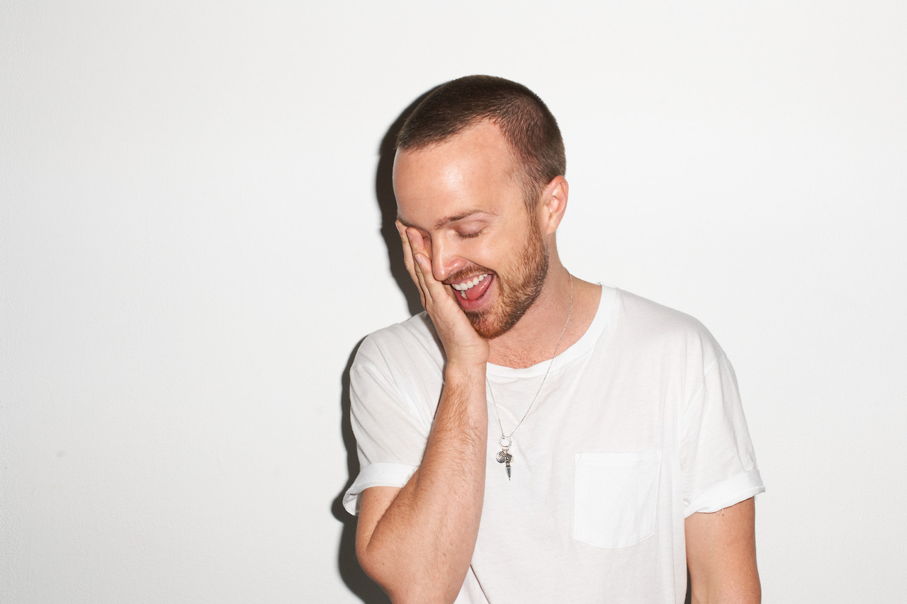

Annie Leibovitz

American born photographer Annie Leibovitz is most famous for her work using bold colour and poses, whilst working at The Rolling Stone.

Her portraiture of both celebrities and subjects aims to show the world the raw emotions of everyone, with her shoots being known for over lavish and expensive set designs that later lead to financial problems.

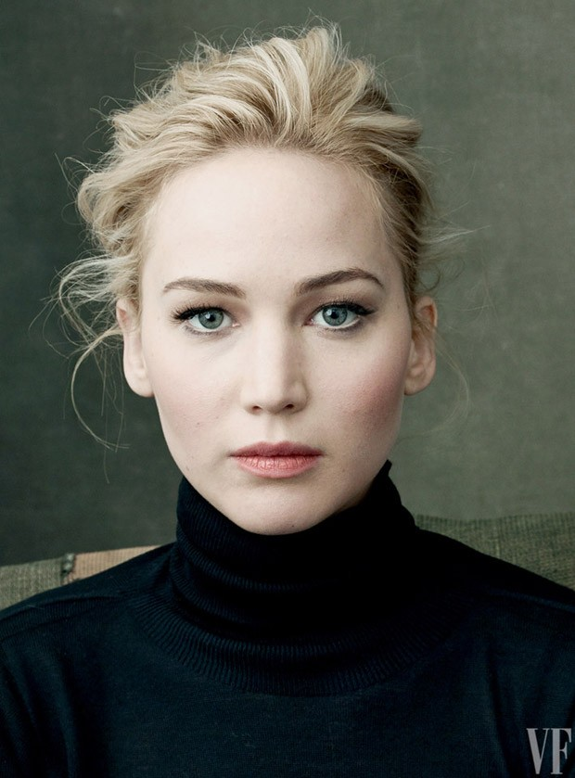
Her influence in classic portraits acts as a large inspiration within my own personal work and photography that will appear within this project, a combination of Leibovitz and Richardson could create a unique portfolio of photographs ready to be projected.

Viral Photographs and Campaigns

Sometimes a certain image or campaign can be purposely or accidently created that generates a storm of attention and oversharing.

Viral photographs have spread through social media, news networks and device to device since photography became mainstream, but the main message behind a photograph becomes the lasting conversation.

“The Envision Cube” is looking to create this lasting impression, an image is a visual attention getter, however if the conveyed statement isn’t remembered then the photograph has failed its purpose.

Some examples of viral images and campaigns include:

Pokémon Go

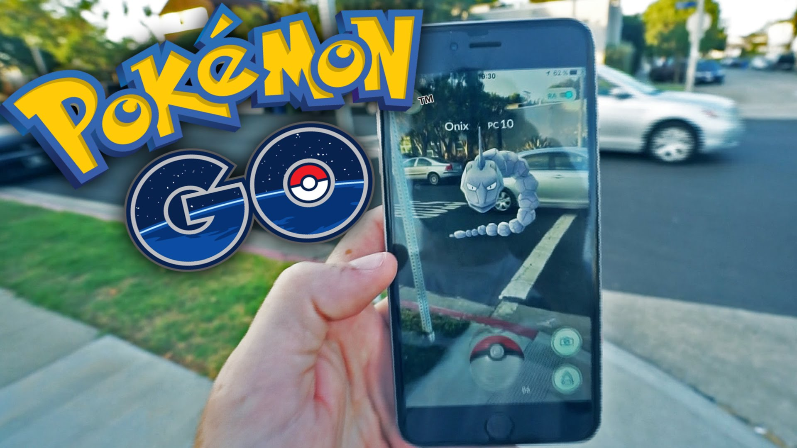
The hit 2016 game for android and IOS, Pokémon Go wasn’t just another addition to the ever-expanding Nintendo Catalogue, but became a viral success due to its unique concept and marketing around “exercise”.

A game that got the kids outside, walking, running and hiking to catch as many Pokémon as they could, the game was boosted through advertisement, but they message remained the same, “got to catch them all” meant travelling, it became the literal game on the go.

Women’s March 2017

A more recent example of viral imagery conveying an important message came in the form of a western uprising against President Donald Trump.

Millions of women, men and children took to the streets of U.S cities, Canadian cities and European Cities to protest Trump.

The images were quickly spread across social media, including Twitter and Instagram and sparked a global movement that is still on-going currently, this kind of viral photography inspired “The Envision Cubes” message of future thoughts in this ever rapidly changing world.

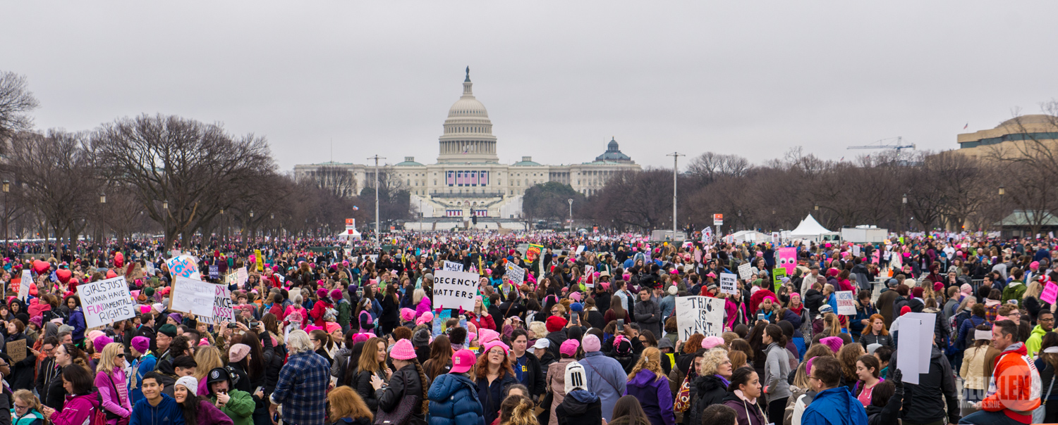
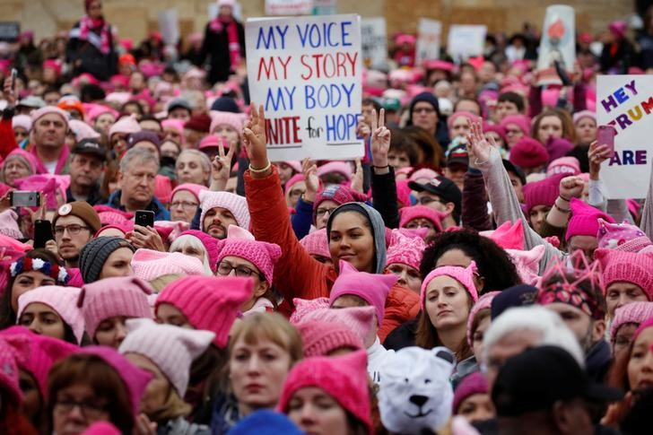
#ITOOAMHARVARD Viral Photography Campaign – Massachusetts, United States.

The #ITOOAMHARVARD campaign went viral when it encourages black students studying at Harvard University to write a message of a board and then pose for a portrait photograph, each message included something asked of them/ said to them by a white student.

The messages were shocking; you can view all of them here: https://www.buzzfeed.com/alisonvingiano/21-black-harvard-students-share-their-experiences-through-a?utm_term=.cdKX6Ekqm#.iqy8z7P6m

The idea behind the campaign is different to the messages I would be looking to showcase, however the style and basic template matches ‘The Envision Cube’ photographical element and so should be included within the research/ inspiration behind this project.
