Research: Project Mapping

Projection mapping uses the basic of 2D projection onto a flat screen and changes the dynamics of the intended surface to create a visual 3D digital spectacle.

The software can be used to turn any object into a surface of projection and is being used currently in a wide variety of industries.

“Projection Mapping The Future Is Here”
https://www.youtube.com/watch?v=PKMCB5v8pt0

Music/ Events

Music videos, both live, pre-recorded or post-production are using projection mapping to create interactive and stunning pieces of art.

SUPER BOWL – KATY PERRY

During the halftime show at the Super Bowl, the use of projection mapping caused the stadium, and specifically the pitch to become a digital landscape, incorporated with Katy Perry’s music and dance routines.
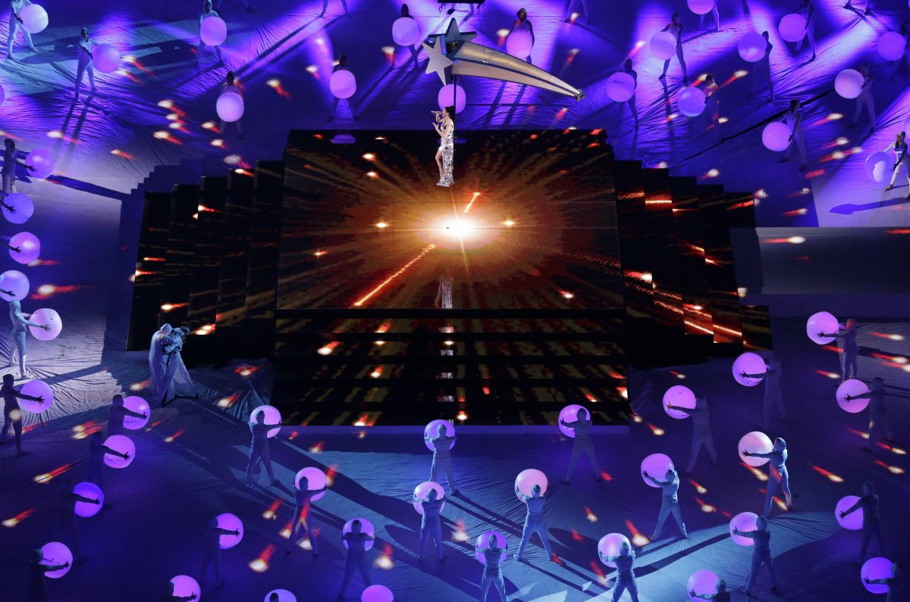
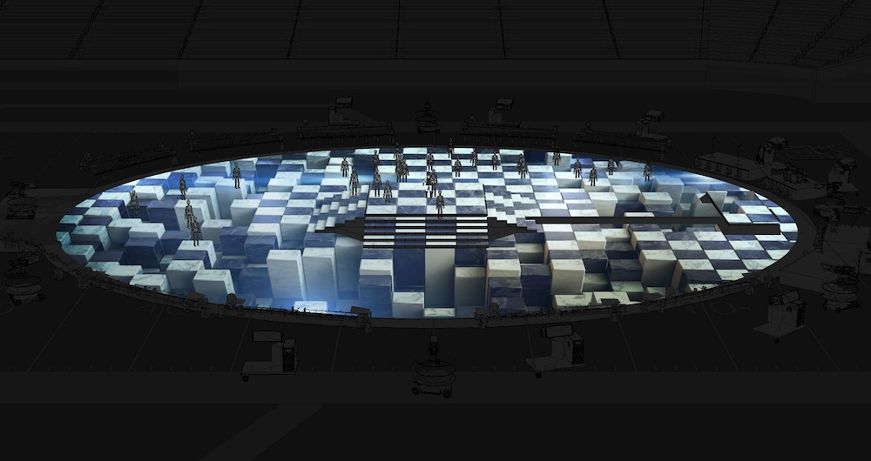

EUROVISION - 2016

Russia’s performance in the Eurovision song content 2016 used projection to create an interactive “climbing wall”, in which the performer could engage with whilst performing the song.

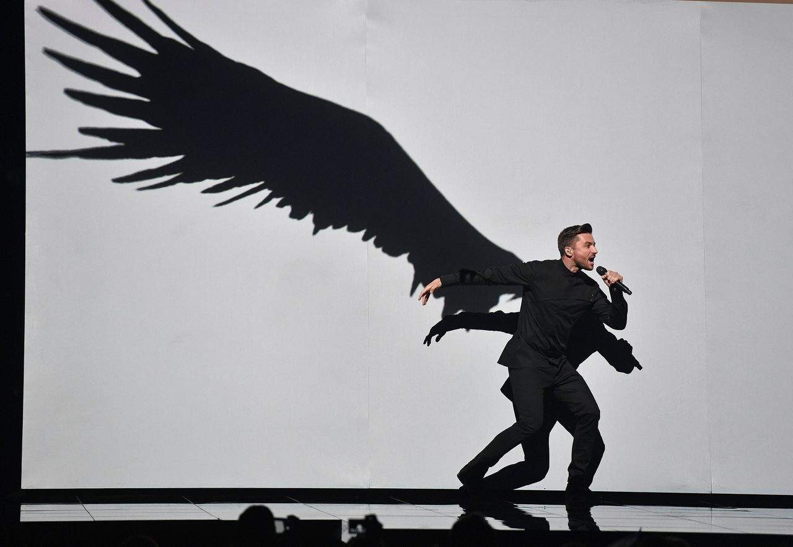
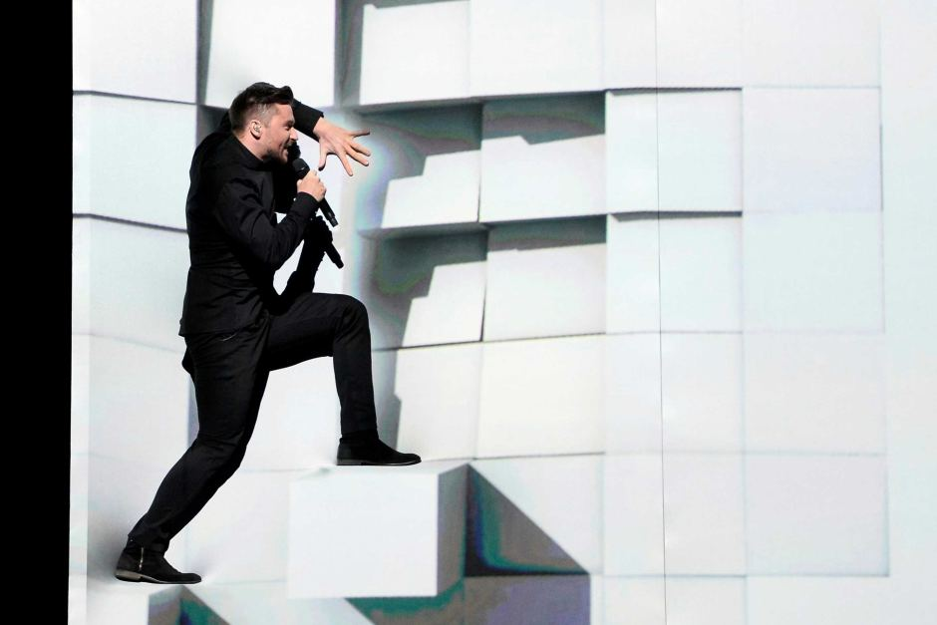

Gaming

The games industry is starting to use projection mapping in terms of advertisement and attraction to various indie projects and some larger scale platforms.

Some work has begun on including projection mapping into an actual game, where the player can choose through various options by simply selecting content, although without a preprogramed selection option this currently wouldn’t working, perhaps a merge between projection and virtual reality is coming shortly.

14 best gaming related PM displays:
http://www.creativebloq.com/video/projection-mapping-912849

INTERCONNECTION:

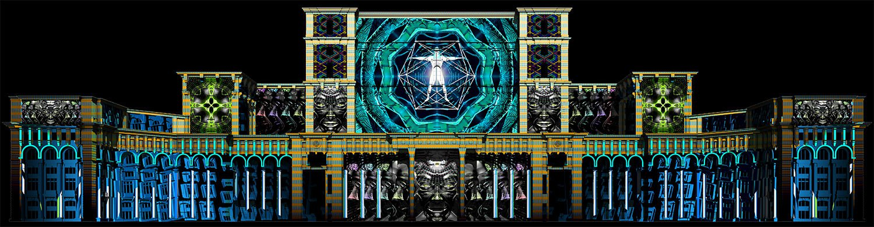
The team behind “Interconnection” Limelight created a digital and technical display projected onto the front of Bucharest’s Palace of Parliament, the work was inspired by Sci-fi themes of gaming, as well as architecture design.

FRAMEWORKS:

Frameworks is looking to explore how interaction can enhance an architectural space, through using augmented reality, projection mapping and gaming controls to create short pieces of in game action, controlled by the player.

The project hopes their work can go on to inspire future game makers into using some form of projection mapping in their work.

Link: https://vimeo.com/14081155

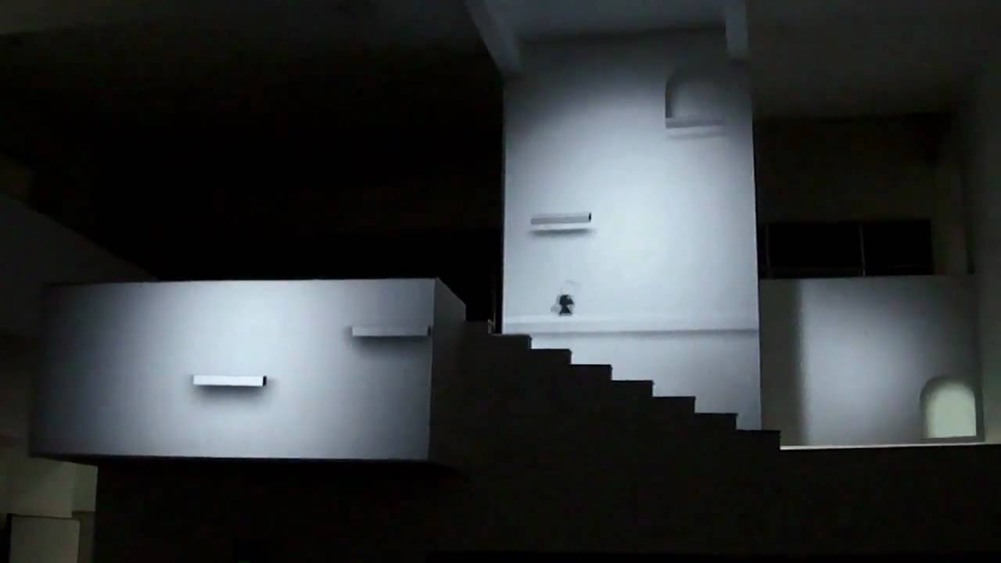
Retail

Marketing and research into interactive selling and advertising, already seen within gaming, has expanding to stores and companies looking to visual engage their audiences.

Projection artworks are working with huge industry companies to create a digital enhancement to their products, to make them sell. Call it creative advertisement, but statistically whether the item is purchased or not, it creates social media attention and competitive competition.

Site Link: http://www.projectionartworks.com/retail

HARRODS – FABERGE

The Faberge/ Harrods collaboration looked to sell their traditional “egg” shaped jewellery using a projection mapped “egg” display, the completed project looked very impressive and was included within Harrods famous Christmas displays throughout their London store.

Link: https://www.youtube.com/watch?v=r18GicZFUmA
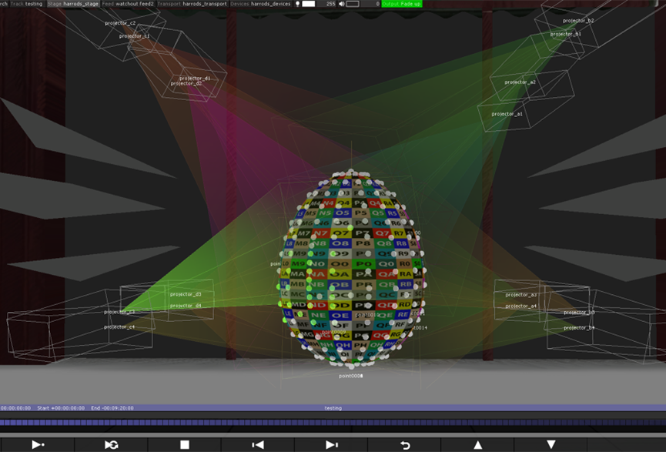
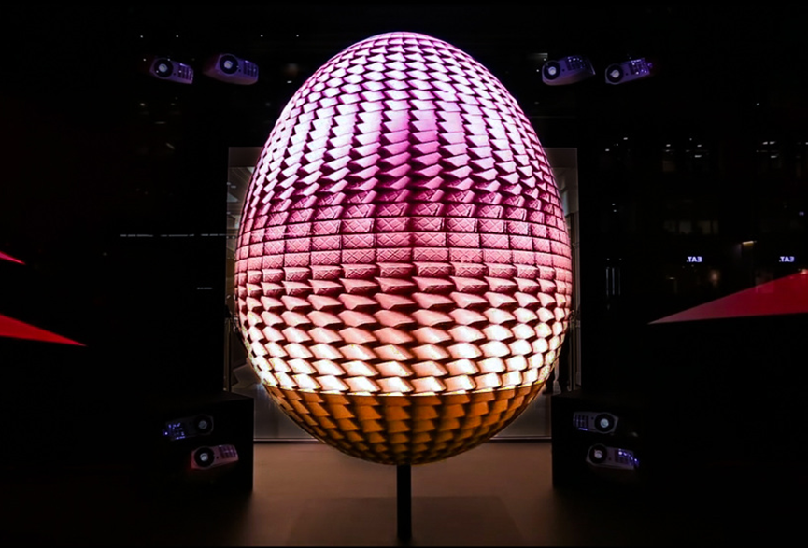

ADIDAS – SUPERCOLOUR

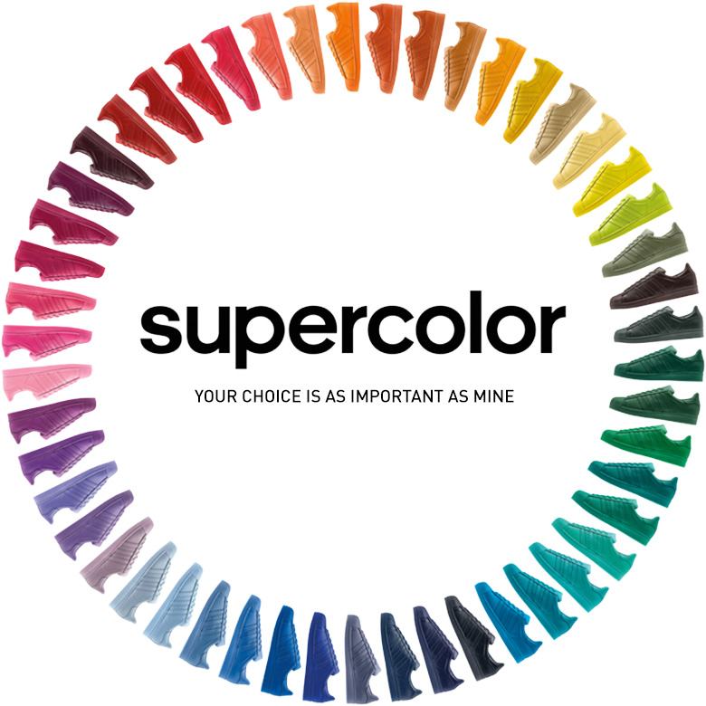
In terms of a smaller example, Projection Artworks worked with Adidas to create a small projection box, that could be manipulated by the public, to change to colour of the advertised shoe.

Simple, but the project showcases a new way to preview available colours/ options of products in retail, now seen through simple click changes on websites.

Link: https://vimeo.com/125555267

Museums

Traditional museums in terms of artefacts, paintings and displays are still very popular, however to reach a younger audience, who are less easy to engage, projection mapping is being used as a source of education.

On displays about dinosaurs, old cities and ruins, projection mapping can show an audience how something use to look, react a historical event or provide information.

INTERACTIVE TERRACOTA WARRIORS – MOESGAARD MUSUEM

A display was created using both 3D modelling initial to create the interactive models and then projection mapping these designs behind an actual artefact of an armour piece.

The display encourages audiences to change the colours of the armour, using colours from the traditional time and then add their personal warrior to the projected display of others.

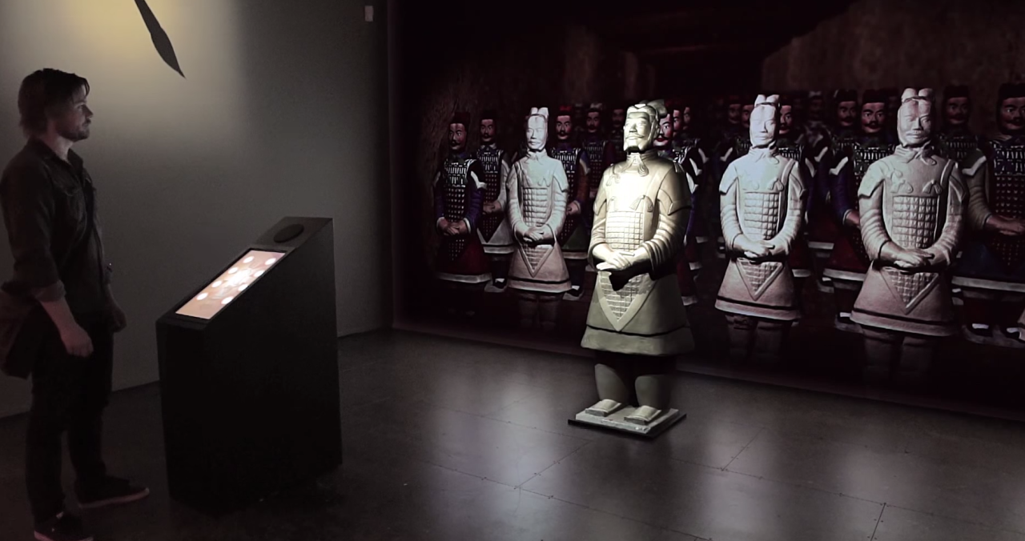
Link: https://www.youtube.com/watch?v=E1Ca4E1p0PE
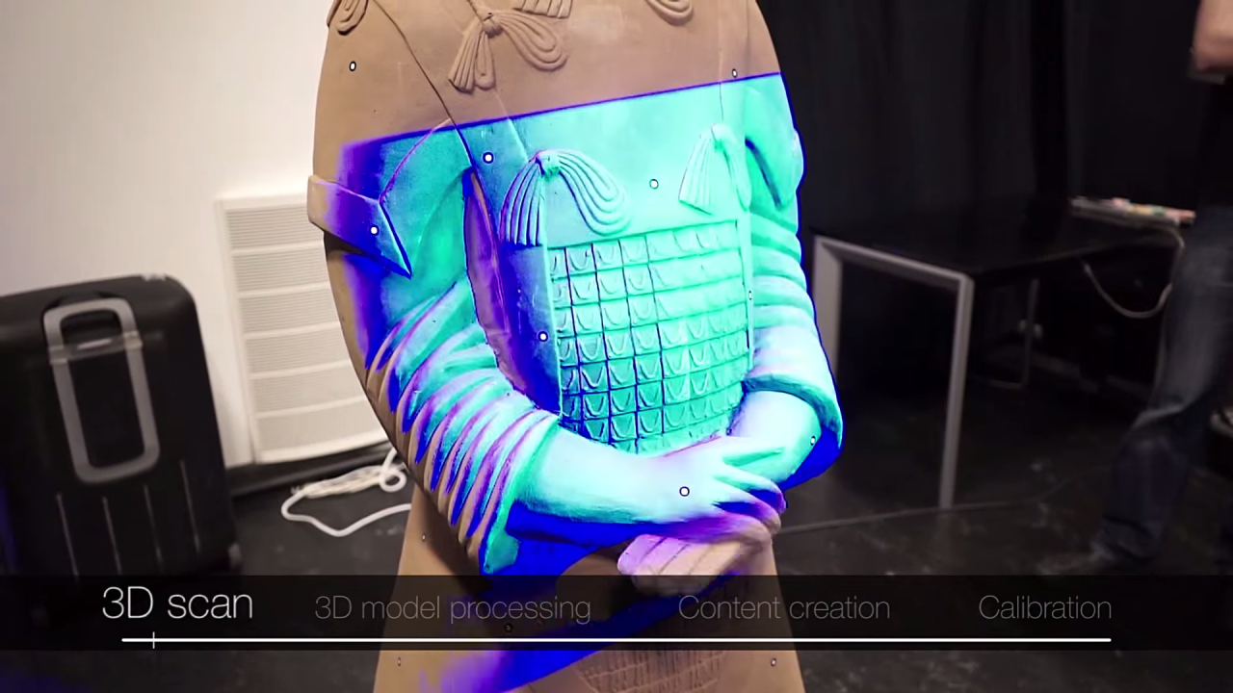

FUTURE OF ENERGY – CHICAGO MUSUEM OF SCIENCE

To show visitors the impact of global energy consumption, without the reading of an “energy table”, the Chicago Museum of Science created a visual education display, using projection mapping.

The project acts as both an education program and interactive game, encouraging users to save as much energy as possible, through several colourful interface options, creating a better “future city”.
