MED3005M Proposal Form - Digital Media

Name(s): Jack Lilley

Date: 21st January 17

Tutor(s): Clive McCarthy. Jon Holmes, Graham Cooper, James Fields.

Working title: The Envision Cube.

What is the intended idea/concept of the project?

‘The Envision Cube’ aims to be a visual and auditory entertainment exhibition, using the power of Projection Mapping to display the final envisions of students as they exit education and enter the ‘real world’.

The objective of this project is a leave a final ‘time capsule’ of a thought or hope, that could be later reflected on by the individual, whilst presented in both photographic and digital forms at the LSFM Degree Show 2017.

A comparison could be made between existing students and later generations by including graduates and working professional’s actual outcomes, also displayed in the exhibition, showcasing the differences between thoughts, success, dreams and outcomes.

The final exhibition will be presented in a blank, dark room, with “The Envision Cube’ lightening up in shades of blue, before beginning the presentation. A selected piece of music/ musical tracks will play to engage the audience senses, with the projectors showcasing the projects photographed subjects.

Some aspects of the project/ presentation will include working with a design student and combining ideas to come up with posters, presentation booklets or post-show memory booklets to give the project a more professional image and quality, these are to be still discussed with Yasmin Palmer, with the final additions including her design and my content.

After the exhibition is completed, a portfolio of all the data/ images collected would be made either via an accessible website, social media account (Instagram) or other source where the project can be permanently archived and updated for participants to reflect upon or access later.

As an audience/ viewer up to 5 projectors will display each individual image of the 5 visible sides of the cube, with the 6th side being the bottom housing the lighting equipment. This will encourage the audience to move around the cube, taking in each section, becoming a 5-sided story, which once pieced together tells the story on the individuals’ future thoughts.

The project will be looking to include several aspects of both Digital Media and various media sectors, making it a challenging but exciting development. Furthermore, the actual cube and lighting rig must be physically designed, through either a D.I.Y building project, or 3D printing (if this is possible) in regards to the cube.

Describe the intended audience:

The final project will be showcased as an interactive exhibition at the LSFM Degree Show 2017, therefore the overall audience will be peers, professionals and members of the public.

The indented audience aims to be firstly the participants, in this case the students, graduates and working professionals, who are asked to envision their thoughts for the future as they exit education, or enter additional further education, after they exited and now working with the industry.

Secondly the viewers of the final exhibition make up the largest section of the intended audience, this could include either gender and age range. The project will only include decent content, (no nudity, swearing, inappropriate content), so if anyone under the age of 18+ years attends, there shouldn’t be any legal issues, expanding the project to the broadest possible market.

Because the intended audience is so broad, justification is required.

The project aims to leave the audience asking questions or reflecting back upon their own experiences with dreams, hope and life choices. By viewing the envisions of students ready to graduate, you can ask yourself whether you achieved your dreams, believed in the same ideas when a similar age, or whether life has disappointed you after School, College, University.

The Graduates and working professional’s inclusion allow older generations to compare themselves and how different envisions/ views have changed over time, prompting further engagement within the archive of photographs, possibly leading to additional entrees.

Similarly, for audience members of the same age and situation, it allows a communication of expressing similar and different fears for the future, encouraging students to acknowledge that they are not alone, many individuals will share the same thoughts,

How will this project extend your creative and technical skills?

This project will include various aspects of both design, digital, audio and photographical elements.

Breaking it down:

- The design will need to include location choice, colour choice, visual elements, physical design of both the cube, layout and lighting. Followed by design of suitable branding and supporting media documentation.

- Digitally, the project will include the use of sound design and projection mapping, something I haven’t practiced in much, therefore setting myself a challenge to create something and learn several new technical skills to achieve this.

- In terms of audio, specific selection and attention needs to be made in the choice or music and perhaps manipulation of a piece through audition, so the piece fits the themes and design of the project. Again, this will be a new skill to learn, through trial and error, and tutorial education.

- The photographic element to the project is something I am already well practiced in, photography is something I have developed as a creative and technical skill for over 7 years, however each portrait of an individual needs to match the others in terms of background, exposure, lighting and post- production. Pushing my photography skills to a professional standard, as if each photograph was to appear on a website, magazine etc.

Most importantly these technical and creative elements need to blend together in the final presentation and appear as one project, if one section appears to let the others down, this will affect the overall exhibition, maintaining that level of professional skill and work management will be a good challenge to successful complete.

Outline how the practical work will be carried out and the time-scales involved for each task. (If working in a group, please also indicate the division of labor):

To achieve each section of the work, a strict breakdown of the time allowed for each part to be completed must be followed, all to be recorded via an online blog:

- (Week 1-2) Initial research and development of the project, including branding, working title, ideas and structure, to be presented in the form of a ‘lightening pitch’ and then a project proposal.

- (Week 3-4) Work out designs for the layout and construction of the cube, exhibition elements. Begin construction of the cube, gather suitable materials and research into lighting installations/ project mapping. Send out requests for photography subjects, secure the studio, equipment and suitable dates, perhaps via a social media page?

- (Week 5-6) Finish the construction and design of the cube, begin photographing participants and gather various content required for the project’s completion, begin developing/ practicing projection mapping techniques (contact Clive for assistants), design the lighting required for the showcase.

- (Week 7-8) Continue photographing individuals and gathering content, set up initial prototype of cube (At Uni or home, take pictures). Begin development of audio accompanying tracks, experiment and create ideas.

- (Week 9-10) Finalize all images and begin post production, finalize the location for the exhibition showcase, whether an initial place or degree show layout. Finalize the audio support material and finalize the projection mapping elements/ inclusion with the photographs. Start the research and development document.

- (Week 11-12) Sign off any remaining work, practice the showcase of all elements before being exhibited, complete the appropriate press pack, finish the research and development document to be submitted with the media project, begin the critical evaluation.

- (Week 13+) Showcase the final ‘Envision Cube’ to its target audience and the public, complete and submit the critical evaluation, receive feedback.
What other work (by animators, designers, film-makers, writers, digital media producers, etc.) is relevant to your project? (This work may either be relevant for its conceptual, inspirational or technical similarity):

The initial work that inspired this idea came from the use of cubes in design and art spaces, particularly museums. Cubes looks aesthetically clean and uniformed, they can be viewed for many angles and present a clean canvas for painting, photography, design, projection and many more presentations.

White Cube Art Gallery – London.

From their website:

“White Cube Bermondsey opened in October 2011 and is the largest of all the gallery's sites, incorporating more than 5440m² (58,000 sq ft.) of interior space. The building, which dates from the 1970s, was renovated and designed by London and Berlin-based architects Casper Mueller Kneer and includes three major exhibition spaces as well as private viewing rooms, office space, a warehouse, an auditorium and a bookshop”.

The main influence from this work is the clean exhibition of their artwork through the form of cubic presentation, which is something I would be looking for demonstrate with ‘The Envision Cube’.

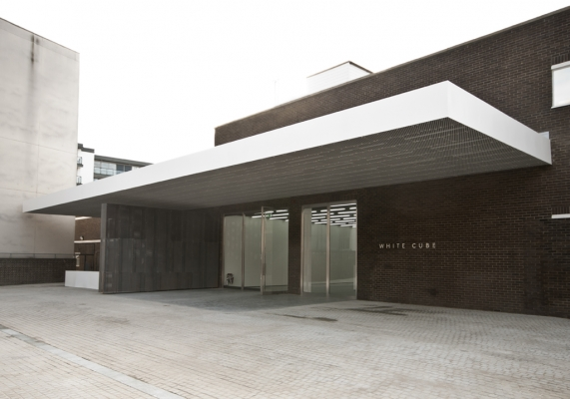
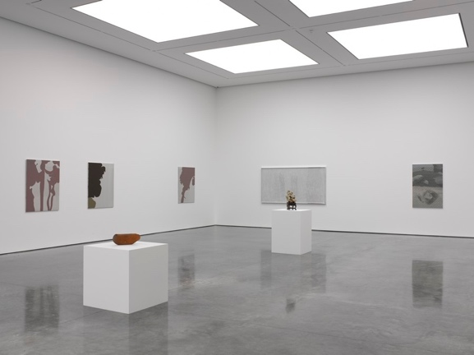

Calvin Harris- This Is What You Came For (Music Video).

In the music video for Calvin Harris’s latest music piece, another artist, Rhianna, is seen dancing in a large cube. The main influence from this work comes from the visual and animation images projected onto the cube, creating a visual masterpiece, that changes to the beat of the track.
Video: https://www.youtube.com/watch?v=kOkQ4T5WO9E

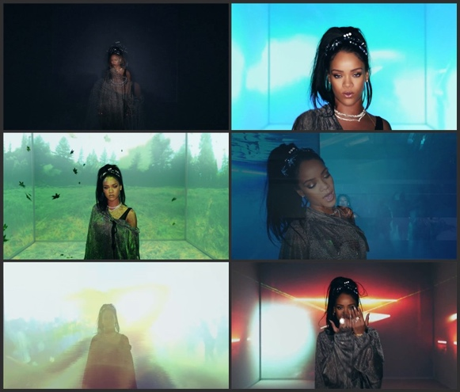
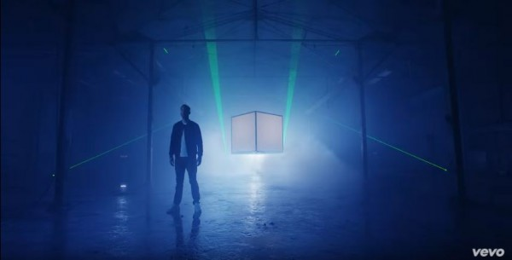
This style will hopefully be mirrored in ‘The Envision Cube’, changing the images to an appropriate track.
Box – The Creators Project.

Box is a 5 minute, visual exhibition, using the power of music and projection mapping to tell a visual story.

From the video: https://www.youtube.com/watch?v=lX6JcybgDFo

“Box explores the synthesis of real and digital space through projection-mapping on moving surfaces. The short film documents a live performance, captured entirely in camera.

Bot & Dolly produced this work to serve as both an artistic statement and technical demonstration. It is the culmination of multiple technologies, including large scale robotics, projection mapping, and software engineering. We believe this methodology has tremendous potential to radically transform theatrical presentations, and define new genres of expression”.
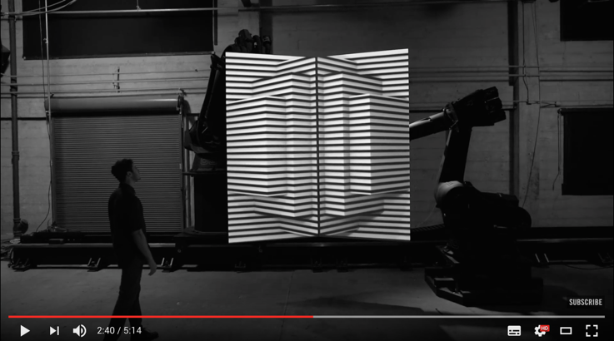
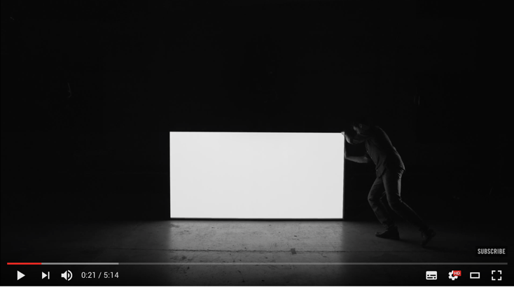

#ITOOAMHARVARD Viral Photography Campaign – Massachusetts, United States.

The #ITOOAMHARVARD campaign went viral when it encourages black students studying at Harvard University to write a message of a board and then pose for a portrait photograph, each message included something asked of them/ said to them by a white student.

The messages were shocking; you can view all of them here: https://www.buzzfeed.com/alisonvingiano/21-black-harvard-students-share-their-experiences-through-a?utm_term=.cdKX6Ekqm#.iqy8z7P6m

The idea behind the campaign is different to the messages I would be looking to showcase, however the style and basic template matches ‘The Envision Cube’ photographical element and so should be included within the research/ inspiration behind this project.
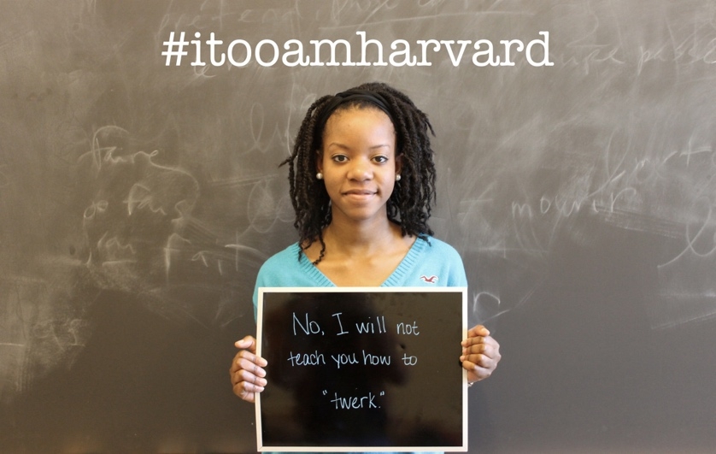
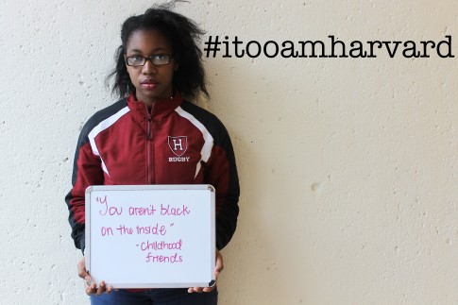
List at least two critical texts that are relevant to your conceptual intentions:

- Christiana, P. (2008) New Media in The White Cube and Beyond Curatorial Models for Digital Art. London: University of California Press.

- Lievrouw, A, L. (2011) Alternative and Activist New Media. Cambridge: Polity.

- Moffitt, A, M. (1999) Campaign Strategies and Message Design: A Practitioners Guide from Start to Finish. London: Praeger.

